SEN Support Plan – Date plan started: Last
My One Page Profile (or insert your current profile)
All about _____________________
My date of birth _________ Hours attending per week ____
Setting: SENCO:

A One Page Profile

Parent/Carers Details
Names:
Address
Contact numbers/Emails

Insert picture of child or something that they are interested in. | Things that make me happy: |  |  | Things I can do myself: |  | Things I need help with:
Things I don’t like: | When I am sad I… |  |  | When I am anxious I …. |  | When I am angry I ….
These things comfort me: | These people help me (e.g., Physio, Speech & Language Therapist): |  |  | Additional comments  Co-produced by -
Support Plan Review (add dates) 1st |  | 2nd | 3rd | 4th | 5th |  | 6th

Key professionals advising the SEN support plan
Name and contact details | Role | Date of last advice

Meetings/conversations to plan and review
Date | Who was involved? | Key points/decisions/actions

Brief family story (including any medical needs)

Parents comments

Outcomes/comments from 2-year check and/or Integrated Review

Additional training completed to support | Date and cost | Impact
Resources (including enhanced staffing) | Date and cost | Impact/evidence of graduated approach working well

Skills/Strengths and ‘next steps’ planning as agreed with parents/carers and child/young/person and supporting professionals
 | Strengths/ Capabilities | Next Steps | How adults will help
Communication and Interaction

Cognition and Learning

Social, Emotional and Mental Health

Sensory and Physical (including medical)

Planning Document for Outcomes as agreed by the education setting, involved professionals, parents/carers and child/young person

This part of the plan must be reviewed & updated at least three times annually, but it may require more frequent reviews depending on the child/young person’s response to the interventions and progress made. Updated pages may be appended to this SEN Support Plan.
Long Term Outcomes – By the End of the Foundation Stage:
Short Term Outcomes (reflecting APDR/Other professional advice/outcome of standardised assessments etc.) Cycle 1 | Review No: | Start date: | Review date:
Outcome of review

Short Term Outcomes (reflecting APDR/Other professional advice/outcome of standardised assessments etc.) Cycle 2 | Review No: | Start date: | Review date:
Outcome of review
Short Term Outcomes (reflecting APDR/Other professional advice/outcome of standardised assessments etc.) Cycle 3 | Review No: | Start date: | Review date:
Outcome of review

Assessments Appendix:
Please attach up to date assessments showing progress over time, using tools appropriate to the needs of the child.
‘The Rochford Review recognises that age-related expectations are not appropriate for a significant proportion of pupils working below the standard of the national curriculum tests, many of whom have SEND that affect their rate of cognitive development or speed of learning. It is important that they have the opportunity to demonstrate both attainment and progress, and that the way we measure their progress accounts for potential differences in the way these pupils learn.’ (page 5) Rochford Review 2016

‘It is important that we are able to measure the progress they make in a way which takes into account the nature of progress for these pupils. Those with SEND can often make progress in different ways to the majority of pupils’ (Page 10 – 11) Rochford Review 2016

Practitioners might find it challenging within the EYFS framework to pinpoint where children with SEND are and to track their progress. We encourage all settings to use a range of resources to help them to accurately identify where a child is in their development.
Examples of assessment tools for Early Years
- Ages and Stages Questionnaires
- Autism Education Trust – Progression Framework
- Birth to 5
- Early Years Development Journal – Council for disabled children
- Speech and Language UK Universally Speaking – The ages and stages of children’s communication development from birth to 5
- Mary Sheridan’s From Birth to Five Years – 4th edition – Ajay Sharma and Helen Cockerill (Routledge, 2014)
- NHS Solent Early Years Developmental Checklist

SENCos may want to use one of the summary sheets below as a way of recording progress -the sheets should reflect the use of more than one assessment tools as well as the practitioners’ professional judgements
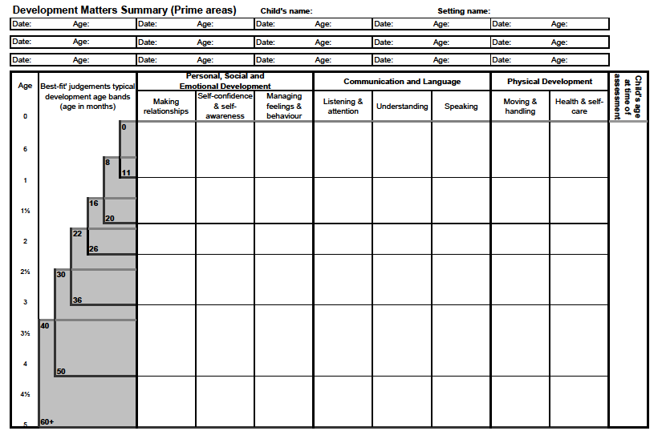
Character
Developmental Assessments Record – this chart can be used to record assessment data obtained using a range of assessment tools using a ‘best fit’ approach.
Date: |  | Age: |  |  | Colour: |  |  | Date: |  |  | Age: |  |  |  | Colour:
Date: |  | Age: |  |  | Colour: |  |  | Date: |  |  | Age: |  |  |  | Colour:
 | Personal Social and Emotional |  |  |  |  | Communication and Language |  |  |  |  |  | Physical Development |  |  |  | Chronological age
Development in months | Making Relationships |  | Sense of Self | Understanding Emotions |  |  | Listening and Attention |  | Understanding | Speaking |  |  | Moving and Handling | Health &Self Care.
0 | Developing
 | Emerging
 | Secure
6
18
24
30
36
42
48
54

60

